**Long Island City Community Boathouse Event Manager**

Table of Contents

Intro

Technical Plan

Team Members

Delegation of Tasks

Components

Dependency Graph

Completion Schedule

GUI Prototypes

Participant Event Registration

Event Management Pages

Volunteer Login

# Intro

Long Island Community Boathouse (LICCB) Event Manager will be a primarily web based event management system for the coordinating, scheduling, user registration, and record keeping of user information. Event coordinators will be able to create, edit, and delete event information. Users will be able to register for events, after which a selection from those users will be accepted as participants. There will be a strict user hierarchy where upon a master user can assign others as event coordinators.

# Technical Plan

This section will describe the services and software stack we will use during the development of the software for LICCB.

|  |  |
| --- | --- |
| **Category** | **Tool** |
| **Communication** |  |
| Email | Gmail |
| Web Conferencing | Google Hangouts |
| Instant Messaging | Google Hangouts |
| **Web Development** |  |
| Environment | Windows |
| Browsers Supported | Chrome, IE11+, Safari, Firefox |
| Frontend | HTML 5, CSS 3, Javascript |
| Backend | PHP |
| Database | MySQL |
| **Collaboration** |  |
| Document Collaboration | Google Drive |
| Version Control System | Git / Github |
| Development Task Delegation | Freedcamp |

# Team Members

Project Manager: Ben Tucker ([btucker@stevens.edu](mailto:btucker@stevens.edu) / [ben.tckr@gmail.com](mailto:ben.tckr@gmail.com) )

Back End Developer: Jake Israel ([jisrael@stevens.edu](mailto:jisrael@stevens.edu))

Larsen Fisch ([lfisch@stevens.edu](mailto:lfisch@stevens.edu))

Front End Developer: William Cusick ([wcusick@stevens.edu](mailto:wcusick@stevens.edu))

# Delegation of Tasks

Ben Tucker

Tasks assigned for the past week:

* Research Freedcamp Project Management
* Assign tasks to group
* Update Preliminary Dependency Graph

Tasks completed for the past week:

* Communicated with Client regarding project resources
* Assigned tasks to group
* Updated Dependency Graph

Tasks assigned for the next week:

* Gui Prototype for volunteer pages
* Communicate design decisions with client

William Cusick

Tasks assigned for the past week:

* Prototype front end pages
* Design navigation layout

Tasks completed for the past week:

* Prototyped Front End Pages
* Design navigation layout

Tasks assigned for the next week:

* Prototype front end pages

Jake Israel

Tasks assigned for the past week:

* Back End Research
* Preliminary Site Design

Tasks completed for the past week:

* Back End Technology Research / Design
* Preliminary site design
* Deliverable Update

Tasks for next week:

* Initial Back End Setup

Larsen Fisch

Tasks assigned for the past week:

* Research database technologies
* Preliminary database design

Tasks completed for the past week:

* Preliminary database design
* Conducted research on database technologies
* Decide on database technology

Tasks for next week:

* Complete relational schema for database
* Initial database setup for testing

# Components

* Back End: apis to connect front end
  + Login/Register
  + Home Page
  + Event Registration
  + Administration Page
  + Event Administration
  + Account Page
* Front End:
  + Splash page for Google Login
    - Integrate with Google API for sign-in
  + New User Registration page
    - Include form for qualification based entries
    - Manage user and volunteer applications
  + Event Registration page
    - Allow users to register for events
    - Display upcoming events
    - Show current registrations
  + Event Management Page
    - Allow Admins to create events
    - ~~Allow volunteers to create events~~
  + User Management Page
    - Limited access to admins/volunteers
    - Display list of registered users
    - Allow admins/volunteers to change permissions
  + Profile Management Page
    - Update preferences
    - Remove self from database
  + Contact Information
  + Privacy Policy

# Dependency Graph

# 

# Completion Schedule

|  |  |  |
| --- | --- | --- |
| Date | Website Front End | Website Back End |
| 9/28/2016 | * ~~Preliminary dependencies for web design~~ * ~~Initial front end layout scheme~~ |  |
| 10/5/2016 | * ~~Preliminary database design~~ * ~~GUI Shots~~ * ~~Event Registration~~ * ~~Updated Dependency Graph~~ | * ~~Technology Design~~ |
| 10/13/2016 | * GUI Shots / Design   - Volunteer Signup  - Volunteer Account  Management | * Preliminary Entity Design |
| 10/20/2016 | * GUI Shots / Design   - Event Creation /  Deletion |  |
| 10/27/2016 | * GUI Shots / Design * Event Management |  |

# GUI Prototypes

* GUI Prototypes contains mockups for current designed pages of the website
* Typical use cases are provided

## Participant Event Registration

1. User signs up as a Participant
2. Participant selects an event
3. Participant Enters Required Information
4. Participant enters discovery info for analytics

1.

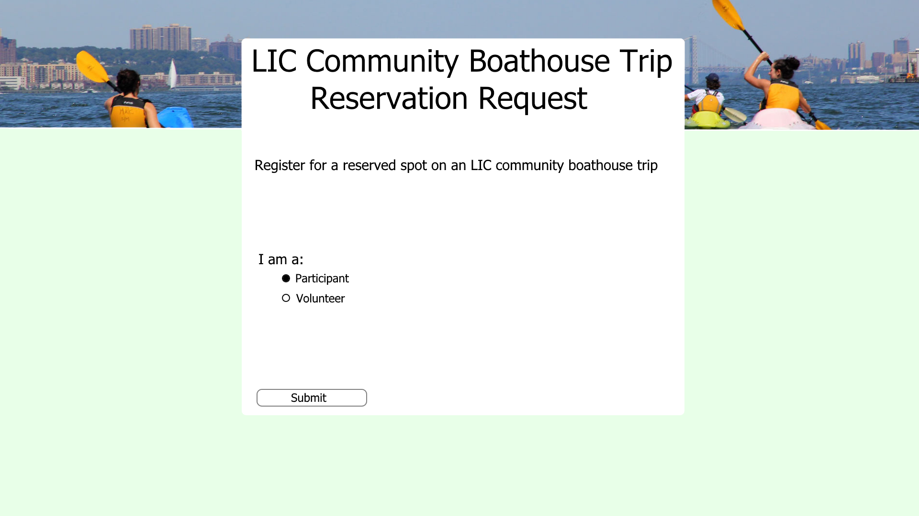

2.

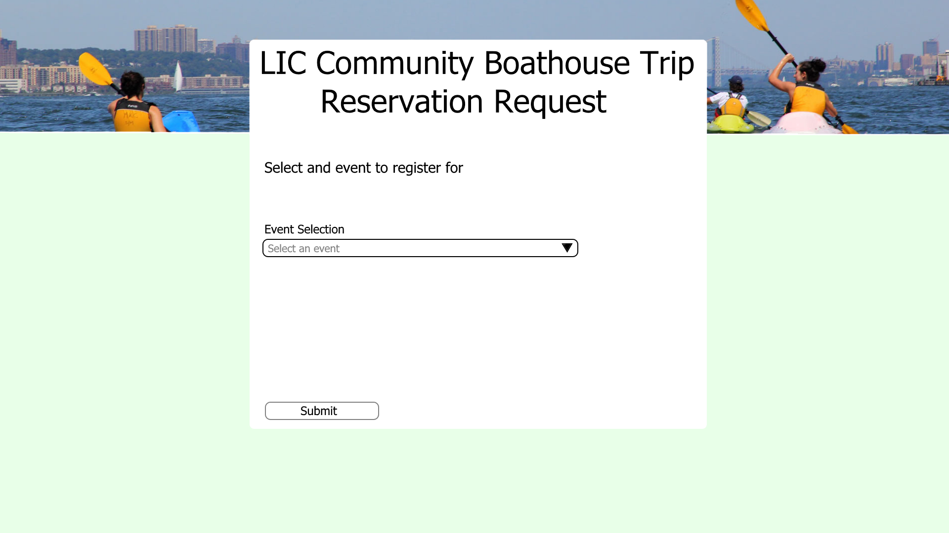

3.

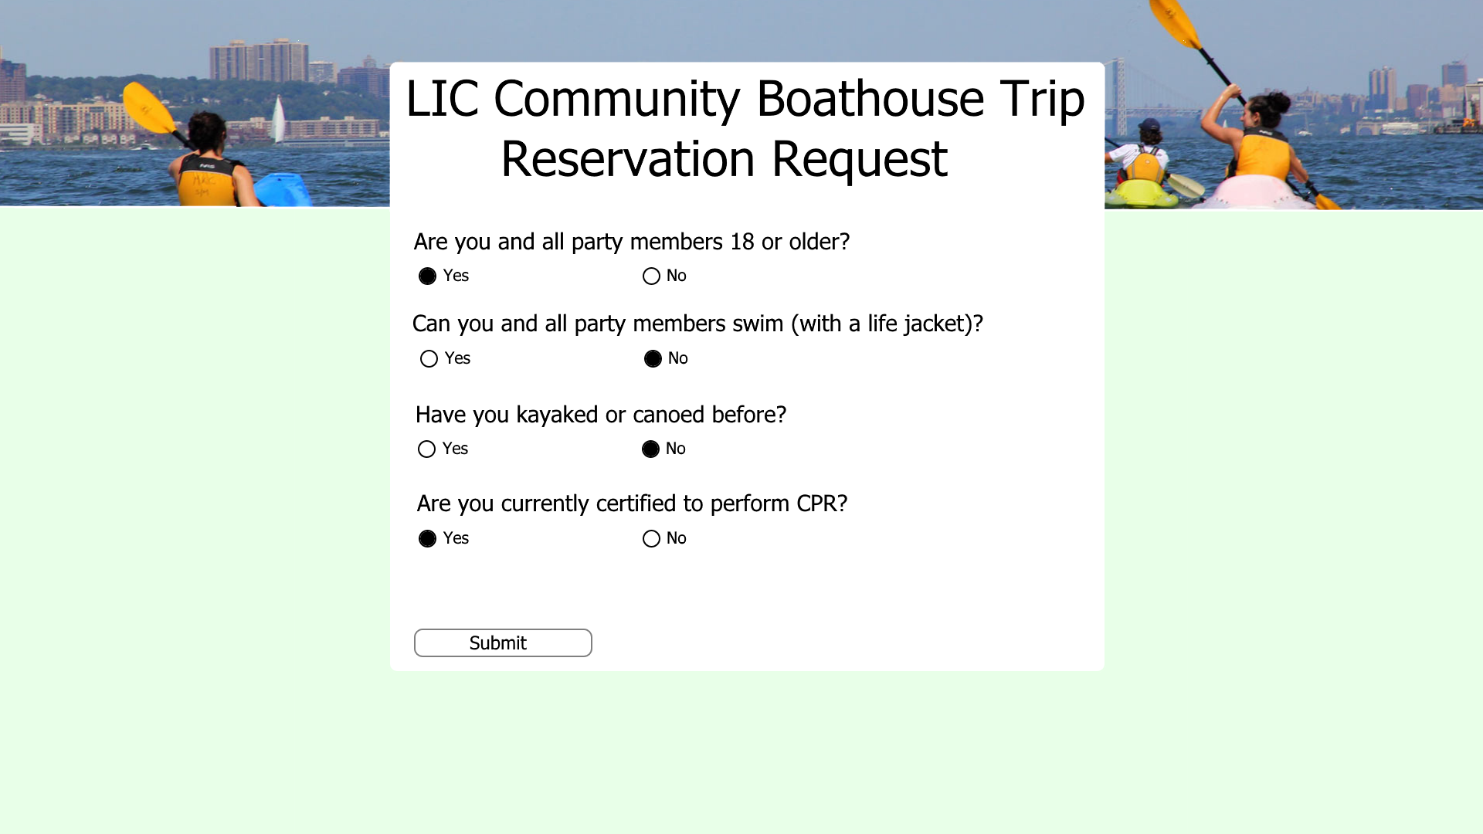

3 cont.

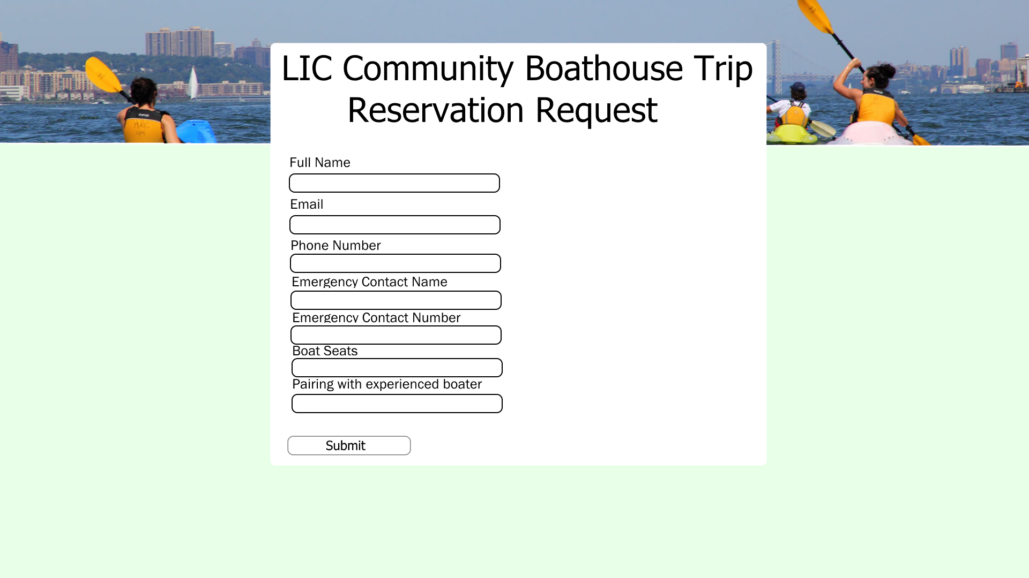

4.

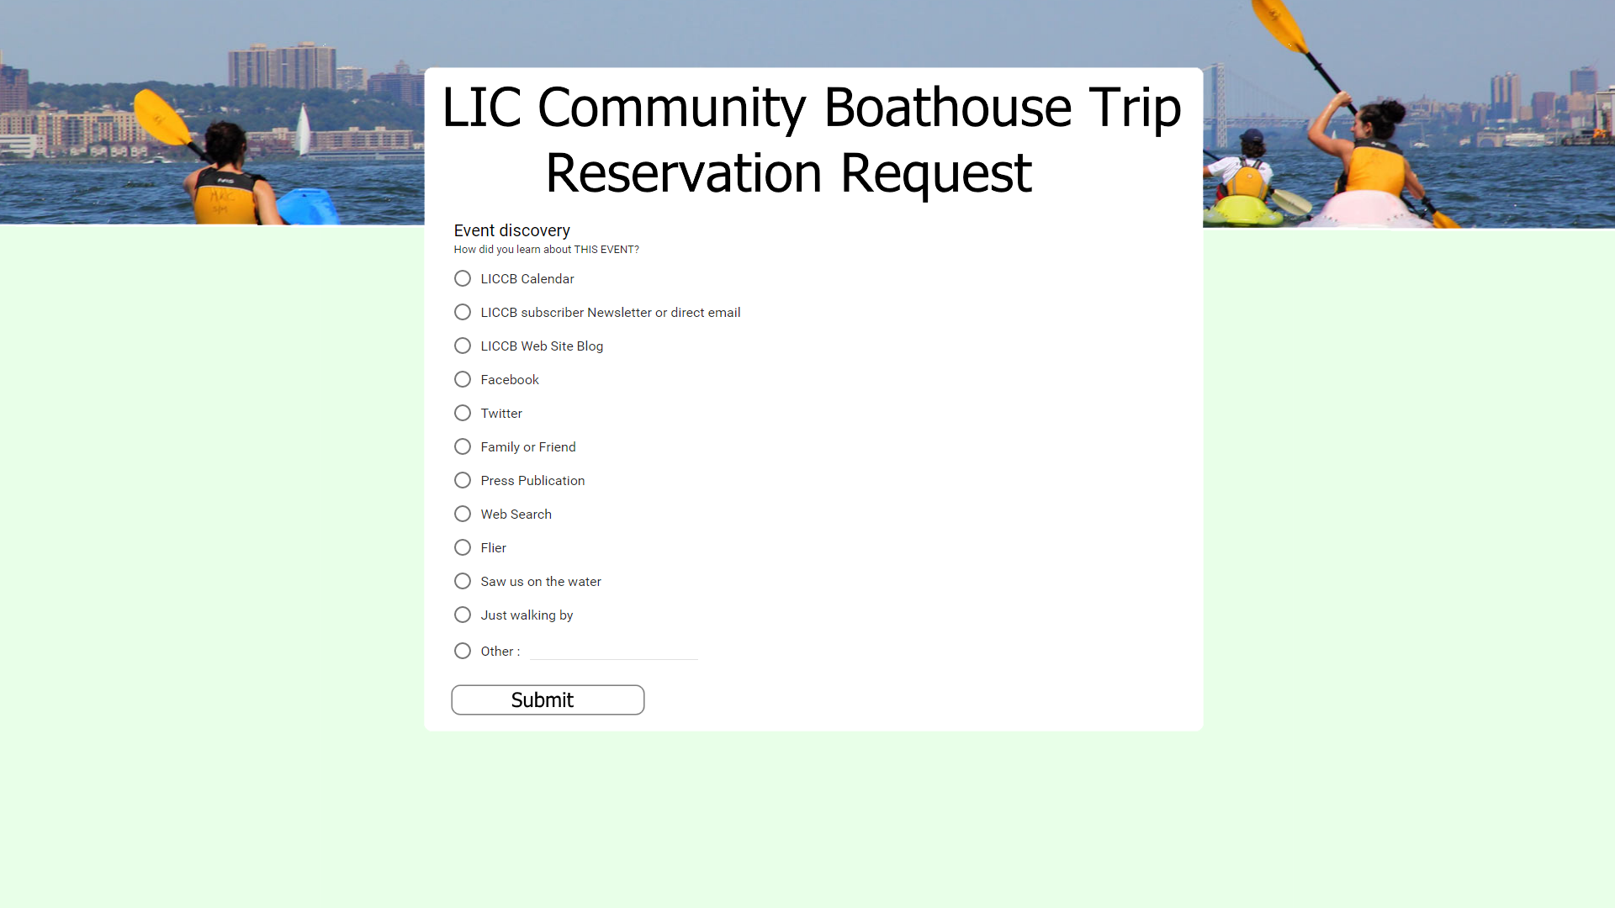

4 cont.

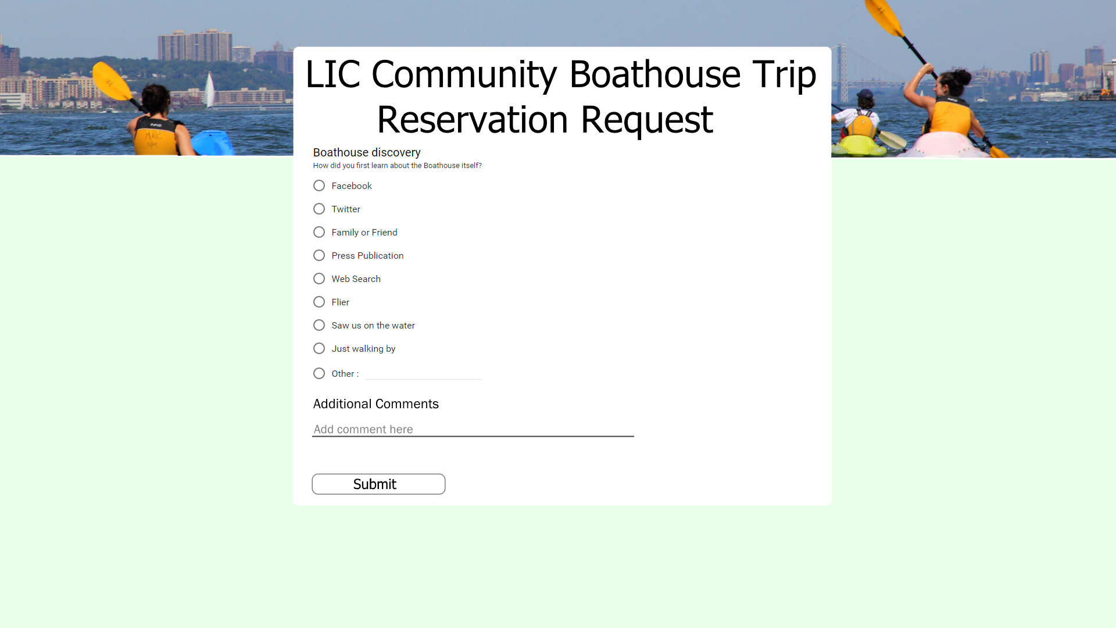

## Event Management Pages

### Volunteer Login

1. Volunteer Logs In to Manage Associated Events

